Anthill x Ipsen Interactive TGR_CORE CLAIMS_V1_CLIENT REVIEW_241114
SECTION 1: KOL introduction video
SECTION 2: Setting the scene: Introduction to NETS

- Gastroenteropancreatic neuroendocrine tumors (GEP-NET) are rare and heterogeneous neoplasms. Fazio N et al, 2017
- Advanced disease is only amenable to palliative treatment and is associated with impaired quality of life.Lamarca A et al, The Oncologist, 2019
- Based on available evidence, stage, primary tumor site, and tumor grade are the cornerstone for treatment planning.Lamarca A et al, Clin Cancer Res, 2019
- The majority of GEP-NETs demonstrate a slow growth rate and fall into G1 to G2 categories whereas G3 tumors are less frequent. Lamarca A et al, Clin Cancer Res, 2019
- The clinical course of NENs is quite heterogeneous, with different spontaneous growth rates after diagnosis, and different degrees of sensitivity to the same
therapy even when they have similar characteristics. Fazio N et al, 2017
- Therapy monitoring based on tumor size changes is associated with several problems as well-differentiated NETs tend to stabilize or initially increase in size even when responding to the treatment.Pettersson OJ, et al. 2021
- Challenges in radiological assessment of response in NETs is well known in the NET community, especially in well-differentiated tumours Lamarca A et al, The Oncologist, 2019

SECTION 3: Why not Watch and wait

- A watch and wait policy has been applied to NEN/NETs since in extremely rare cases they tend to remain stable for a long time.Fazio N et al, 2017
- In NETs the choice is almost always between watch and wait, or SSAs, which are a very low toxic therapy.Fazio N et al, 2017
  - the alternative to W and W is most commonly a low toxic and effective treatment with somatostatin analog. Fazio N et al, 2017

- However, NETs tend to grow even when they have very favorable biological characteristics Fazio N et al, 2017
  - The vast majority of advanced NETs tends to grow and that SSAs can be active even when the tumor is very indolent.Fazio N et al, 2017

- In the CLARINET study, the placebo arm is a surrogate for the watch and wait behavior and both PFS and OS favor the LAN-treated group (“The placebo group in our study may be considered a surrogate for deferred treatment”, CLARINET study)

SECTION 4: Overview of RECIST

- Current practices relies on the use of response evaluation criteria in solid
tumours for a definition of progression or response to systemic therapies. Lamarca A et al, Clin Cancer Res, 2019
- RECIST (response evaluation criteria in solid tumors) represented a major improvement in the evaluation of response to antineoplastic agents in solid tumours, and is frequently employed as the standard way to measure the response of a tumor to treatment.Ferte et al 2013
  - RECIST, introduced in 2000 and revised in 2009, has been widely used as a standardized method for tumor response assessment in the past two decades and has provided the basis for regulatory approvals for novel cancer therapy.Nishino M, et al
- A sum of the diameters (longest for non-nodal lesions, short axis for nodal lesions) for all target lesions is calculated and reported as the baseline sum diameters.Eisenhauera EA, et al. 2008
- Response evaluation is based on a percentage comparison between the measurement of several target lesions at the start of treatment, and at specific time points during the course of a treatment.

- The comparative measurments are transformed into a categorical variable
(complete response [CR], partial response [PR], stable disease [SD], or pro- gressive disease [PD]) [1, 2]. Dromain et al 2019, Clarinet post-hoc analysis
  - Complete response – disappearance of all target lesions
  - Partial response – at least 30% decrease in maximum diameters
  - Stable disease – between 30% shrinkage and 20% growth
  - Progressive disease – At least 20% increase in maximum diameter or any new lesions.

(Design note: Animate image below to create simple video, with each category appearing sequentially.)

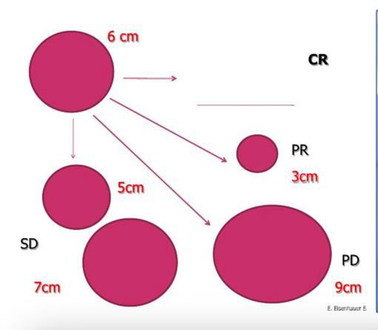

SECTION 5: RECIST has limitations /Is RECIST sensitive enough to detect subtle tumor changes in NETs?

Can we say something about – RECIST only take diameter into account, and not tumour growth kinetics. It is not sensitive enough. Can we say RECIST is one dimensional measurement? Tumor size versus tumor kinetics.

- The slow-growing nature of neuroendocrine tumors (NETs) can confound the accurate assessment of disease status using RECIST criteria. Dromain et al 2019,
- In NETs, the application of RECIST to evaluate therapy benefit, is associated with several problems:
  - RECIST categorization is based on changes in lesion diameter. However, it does not take into account tumor volume and growth kinetics (From TGR slides)
  - RECIST evaluations does not take into its pre-treatment component, making it challenging to discriminate between treatment response, or the natural course of the disease.(From TGR slides)
(Design note: Animate image below to create simple video, with each trajectories appear sequentially.)

- RECIST has also been challenged in the assessment of response to treatment like sunitinib and compared to other criteria such as Choi

- Limitations of RECIST to patients with NETs:

  - Various treatments lead to various anti-tumor effects

  - NETs are heterogeneous and mostly slow-growing

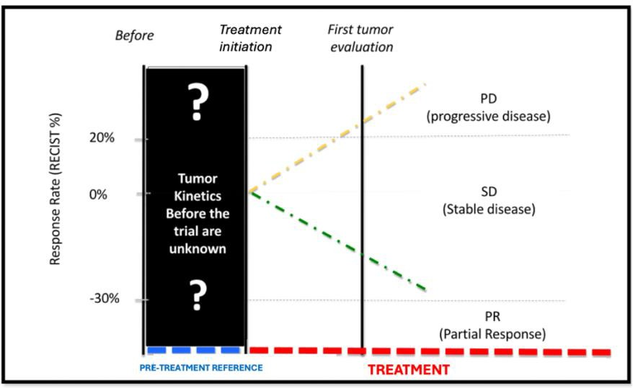

Scenario 1 - Apparent lack of treatment benefit in a fast-growing tumor
Fast growing tumors are more likely to be classified as stable or progressive disease, whereby the treatment appears ineffective. This may lead to treatment discontinuation, despite that the fact that drug actually offers antitumor activity. Ferte et al 2013

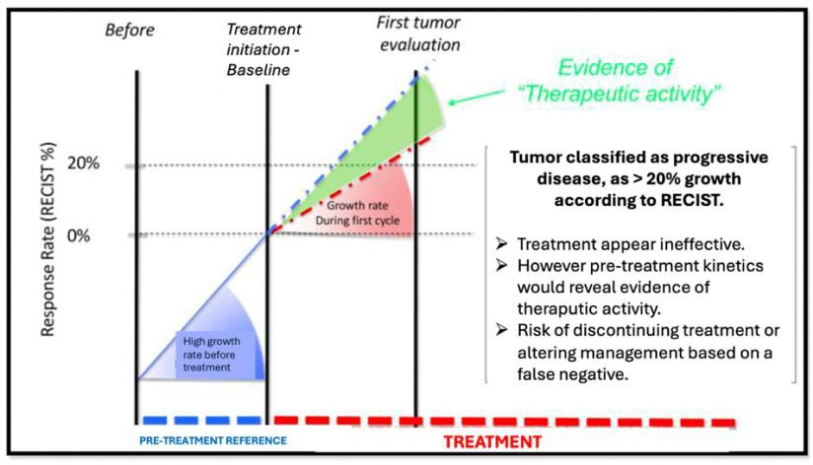

Scenario 2 - apparent lower-estimation of treatment benefit in a slow growing tumor eg NETs
Conversely, in a non-active drug configuration, slow-growing tumors are likely to be classified as stable disease, whereby the treatment appears effective. This may lead to continuing the patient’s unnecessary exposure to the drug, despite the fact that it offers no antitumor activity.Ferte et al 2013

- Additionally, well-differentiated NETs tend to stabilize or initially increase in size even when responding to the treatment, further compounding the accuracy of RECIST evaluation(Pettersson et al. 2021)
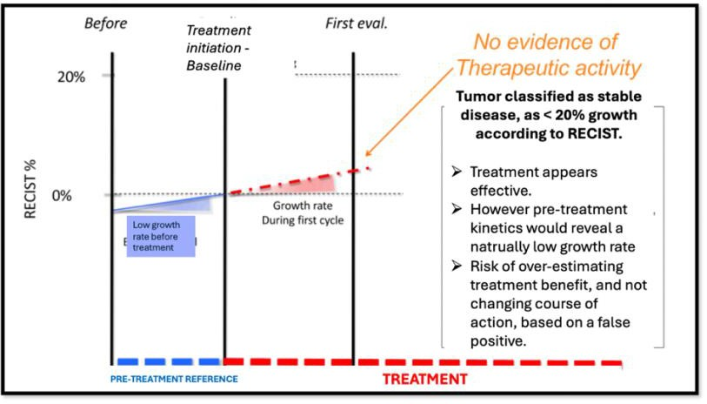

Why is this relevant?:

- As a result, it can be difficult for practitioners to decide how to adapt treatment.
Dromain C et al. 2019, Clarinet post-hoc analysis
- New objective measures of tumor response that can detect subtle changes in tumor growth are needed to complement RECIST Rusznieweski slides.
- NETs are heterogeneous and some patients may require a closer follow-up/more frequent monitoring, there is a need for an adapted tracking tool (“TGR is an early radiological biomarker able to predict PFS and to identify patients with advanced NETs who may require closer radiological follow‐up.”

SECTION 6: Introducing TGR – brief overview of TGR

- Tumour Growth Rate represents a more sensitive method to evaluate early objective treatment response within NETs, offering prognostic insight into disease biology, PFS and overall survival.
  - First described by Ferte et al, and applied to a retrospective analysis of radiological data from multiple phase 1 oncology trials across mutiple tumor types. Ferte et al 2013
  - Tumor growth rate has become a metric of progression in individual studies involving many types of tumors, such as adenoid cystic carcinoma, hepatocellular carcinoma, non-small cell lung cancer, renal
cell cardinoma and neuroendocrine tumors. (He et al, Grande et al, Fukuda et al, Lamarca et al, Chen et al)

SECTION 7: TGR in detail

- The tumor growth rate (TGR) estimates the increase of the tumor volume over time (published formulation.TGR Slides
- It incorporates the time between the imaging examinations, allowing for a quantitative and dynamic evaluation of the tumor response.TGR Slides
- TGR is expressed as a percentage increase in tumor volume over 1 month and is based on data from 2 CT/MRI examinations and the time between these investigations.
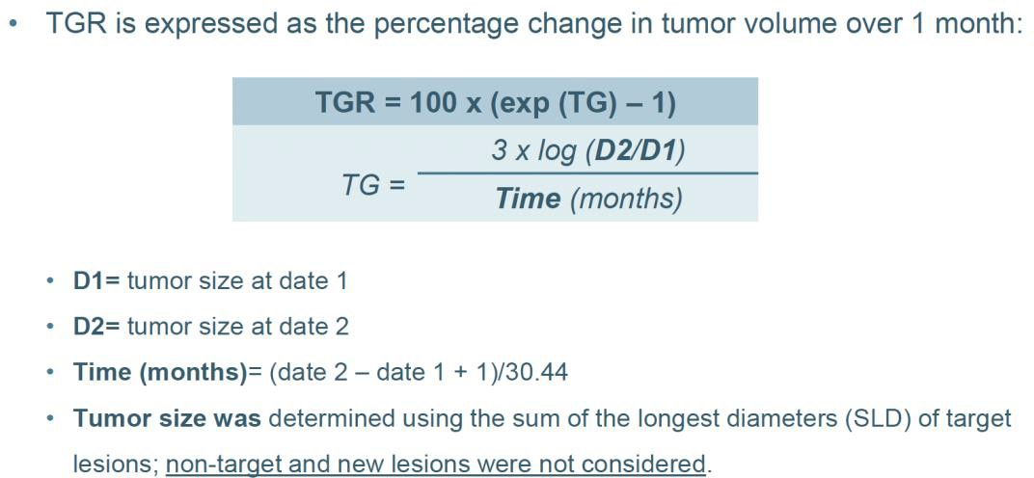

SECTION 8: TGR can help identify NETs patients at risk of progression, despite RECIST indicating stable disease.

- In the GREPONET study, TGR was able to measure changes in tumor size that RECIST is not able to identify, thus providing a more granulated and accurate assessment.Lamarca A, et al 2019. Greponet 1

- GREPONET 1 showed that TGR can be used for risk stratification of patients at an early stage (3 months) after starting systemic treatment. Lamarca A, et al 2019. Greponet 1

GREPONET 1: Study overview

- GREPONET 1 was a retrospective, multicentre study to invesigate the utility of TGR as a novel outcome measurement in NETS. Lamarca A, et al 2019. Greponet 1

  - Patients had been diagnosed with grade 1 or grade 2 NETs in the pancreas or the small bowel; diagnosed with advanced stages at study entry (n=222). Lamarca A, et al 2019. Greponet 1

  - The study included patients on all forms of systemic therapy (including SSAs), chemotherapy, targeted agents, and peptide receptor radionuclide therapy [PRRT]) or watch and wait. Lamarca A, et al 2019. Greponet 1

- The primary objective was to evaluate whether TGR3m after starting treatment and/or follow-up (for patients on watch and wait) was a factor predictive of progression-free survival (PFS). Lamarca A, et al 2019. Greponet 1

Results (combined TGR0 and TGR3m):
- Both TGR pretreatment (TGR0) and TGR at 3 months (TGR3m) of starting
systemic treatment (ST) or watch and wait (WW) were explored and showed that patients with high TGR (≥4%/m) and TGR3m (≥0.8%/m) had shorter progression free survival [PFS; HR . 2.2; 95% confidence interval (95% CI,1.1–4.3) and HR 3.8; 95% CI, 2.2–6.3, respectively]. Lamarca A, et al 2019. Greponet 1

TGR3m specific: TGR3m was found to be an important cutoff in the prediction of patient’s outcome. Lamarca A, et al 2019. Greponet 1
- Patients with TGR3m ≥ 0.8 (vs. <0.8) had shorter PFS (hazard ratio [HR] 2.13; 95% CI, 1.34–3.37; p = .001; Fig. 2A) and higher risk of progression at 12 months (OR, 14.99; 95% CI, 5.09–44.19; p < .001). Lamarca A, et al 2019. Greponet 1

  - At 12 months, 92.74% in the TGR3m <0.8 group were expected to be free from progression, whereas and 43.18% of patients in the TGR3m
≥0.8 group were expected to be free of progression (equivalent to 12 month progression rate of 7.26% and 56.82%, respectively). Lamarca A, et al 2019. Greponet 1

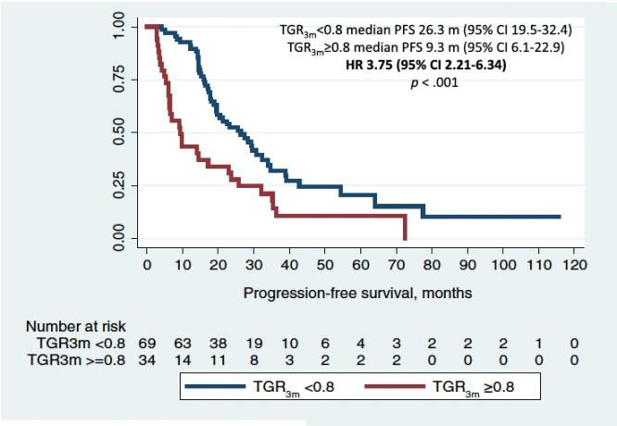

Pre-treatment TGR specific: Pre-treatment TGR was also shown to be independently associated with progression free survival. Lamarca A, et al 2019. Greponet 1

- Multivariable analyses showed that small bowel primary tumor (vs. pancreas; HR, 0.41; 95% CI, 0.18–0.94; p = .036) and TGR0 ≥ 4%/m (HR, 2.22; 95% CI, 1.15–
4.31; p = .018; were independent factors related to longer and shorter PFS, respectively. Lamarca A, et al 2019. Greponet 1
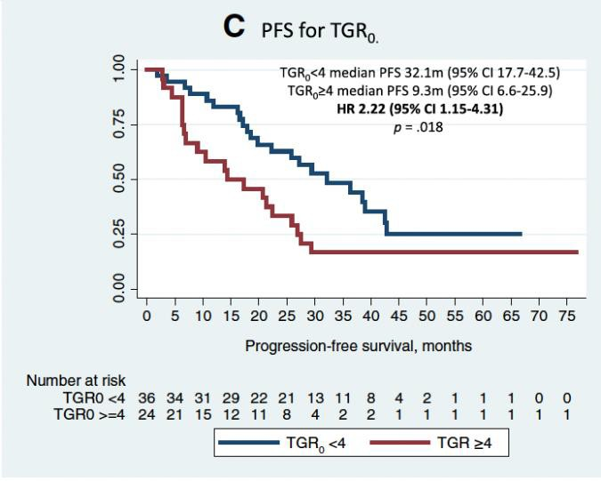
TGR is an early radiological biomarker able to predict PFS and to identify patients with advanced NETs who may require closer radiological follow-up: Lamarca A, et al 2019. Greponet 1

GREPONET STUDY 2:

GREPONET 2 was a follow-up study, in an independent cohort, with the goal of
validating previous TGR cut-offs, investigating the ability of TGR to identify objective
radiological response at 3 months (TGR3m-BL), and further investigating the correlation with PFS and overall survival. Lamarca A, et al 2019. Greponet 2
The GREPONET-2 study addressed 2 main questions:

GREPONET 2 STUDY OVERVIEW:

- GREPONET 2 was a retrospective, multicentre study to investigate the utility of TGR as a novel outcome measurement in NETS. Lamarca A, et al 2019. Greponet 2

  - Patients had been diagnosed with grade 1 or grade 2 NETs in the pancreas or the small bowel; diagnosed with advanced stages at study entry (n=127). Lamarca A, et al 2019. Greponet 2

  - The study included patients on all forms of systemic therapy (including SSAs), chemotherapy, targeted agents, and peptide receptor radionuclide therapy [PRRT]) or watch and wait. Lamarca A, et al 2019. Greponet 2

- The primary objective was to evaluate whether starting any ST (including "WW") produced any absolute intrapatient changes on TGR (i.e. TGR3m-BL). Lamarca A, et al 2019. Greponet 2

In the GREPONET 2 study, for TGR0 and TGR3m, previously identified cut-offs [4%/m for TGR0 (14) and 0.8%/m for TGR3m (11)] were used for survival analysis. Lamarca A, et al 2019.
Greponet 2

GREPONET 2 RESULTS:
ΔTGR3m-BL specific: TGR is able to detect subtle changes in tumor volume, early on in treatment duration. Lamarca A, et al 2019. Greponet 2
- ΔTGR3m-BL identified subtle variations in tumor volume that would otherwise have been missed (i.e., classified as stable disease despite having reduction in tumor size) by only applying RECIST v.1.1. Lamarca A, et al 2019. Greponet 2

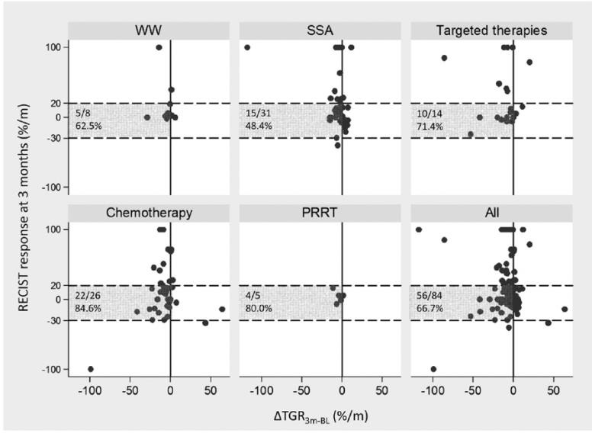
- These changes in ΔTGR3m-BL were identified in patients receiving SSAs, targeted therapies and chemotherapy, whereas patients on WW had similar paired TGR0 and TGR3m Lamarca A, et al 2019. Greponet 2

Validation of TGR3m: TGR3m has been validated as an independent factor related to shorter PFS. Lamarca A, et al 2019. Greponet 2
- TGR3m was significantly lower in patients who later achieved partial response by RECIST 1. This supports the notion that a low TGR3m may be used as an early indicator of favourable therapy outcome, not only in terms of PFS but also as an early marker of radiologic objective response. Lamarca A, et al 2019. Greponet 2

- A high TGR3m was identified as an independent factor related to shorter PFS, suggesting that TGR3m does have more of a biological relevance than other TGR- derived parameters. Lamarca A, et al 2019. Greponet 2
  - i.e. achieving a low TGR3m (<0.8%/m) has more relevant impact on survival, regardless of TGR0, DTGR3m-BL, or the treatment employed.

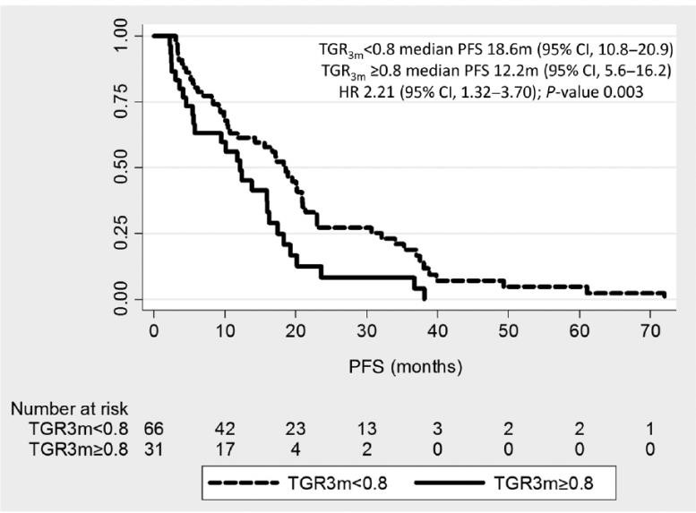

SECTION 9: CLARINET – TGR identifies early response to lanreotide in the treatment of NETS Dromain C, et al. 2019
- The CLARINET core study demonstrated the antitumor efficacy of lanreotide depot/autogel 120 mg/4 weeks in patients with non-functioning intestinal/pancreatic NETs compared with placebo.Dromain C, et al. 2019
- The CLARINET open-label extension confirmed long-term safety and efficacy of lanreotide. Dromain C, et al. 2019
- CLARINET POST-HOC analysis was desgined to re-evaluate [data from the CLARINET core study, and extension] and explore the utility of TGR as: Dromain C, et al. 2019

- A measure of tumor kinetics both before and in response to treatment
- A prognostic factor for progression free survival

TGR to measure kinetics before treatment:

- Despite 96% of CLARINET patients were considered stable acording to RECIST, during the pre-treatment phase, they were progressing at a mean of 4% per
month. Dromain C, et al. 2019
  - The CLARINET study demonstrated that a significant proportion of
patients would have been classified as stable disease by RECIST v1.1 at 3 months, despite showing a reduction of TGR3m-BL Dromain C, et al. 2019

TGR to measure progression during treatment:

- Unlike RECIST, TGR revealed the antitumor effects of lanreotide as early as 12 weeks. Dromain C, et al. 2019

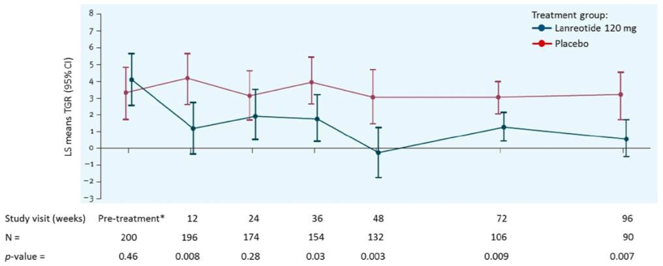

- It was found that a value of 4% during screening was optimal for predicting the risk of progression. Dromain C, et al. 2019
- Lanreotide was significantly more effective than placebo at reducing the risk of PD/death, by 73% and 63% respectively in those with ≤4% and >4% respectively.
Dromain C, et al. 2019

TGR as a prognostic tool: Pre-treatment TGR was a prognostic factor for PFS outcomes. Dromain C, et al. 2019
- When comparing PFS between TGR0 subgroups, TGR0 > 4%/month was associated with a four-fold greater risk of PD/death than TGR0 ≤ 4%/month in the overall population (HR 4.1 [95% CI [2.5– 6.5]; p < 0.001, n = 187). Dromain C, et al. 2019

- Pre-treatment TGR was prognostic for PFS, as a 10% increase resulted in a 2.9 fold greater risk of progression (hazard ratio 2.9 [95% CI 2.1, 3.9]; p<0.001; n=187). Dromain C, et al. 2019

- Lanreotide was significantly more effective than placebo at reducing the risk of PD/death, by 73% and 63% respectively in those with ≤4% and >4% respectively.
Dromain C, et al. 2019

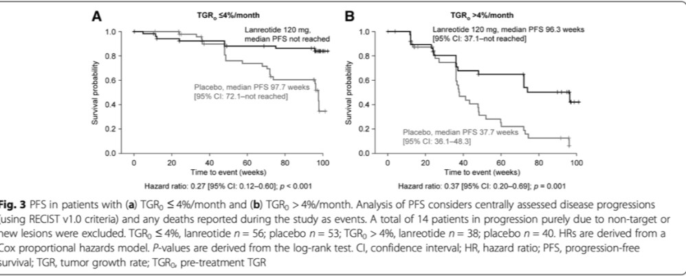

SECTION 10: Clinical implications: How can TGR better inform treatment decision making in NETs?

Mounting evidence supports the use of TGR as an early radiological biomarker able to identify tumor progression, treatment response and prognosis in patient with slow growing NETs
- TGR offers a more dynamic insight into tumour biology than RECIST and is able to detect early and subtle treatment response, allowing tailoring of patient
management and follow up and informed treatment decision making Lamarca A, et al 2019. Greponet 2
- TGR3m may be used as an early indicator of favourable therapy outcome, not only in terms of PFS but also as an early marker of radiologic objective response.
Lamarca A, et al 2019. Greponet 2
  - TGR3m is likely to be more informative than RECIST 1.1 for early treatment evaluation at 3 months after treatment initiation, to identify subtle changes in tumor growth and treatment activity. Lamarca A, et al 2019. Greponet 2
  - TGR3m is able to identify patients at high risk of tumour progression early on after treatment initiation.
  - A high TGR3m (>0.8) relates to shorter PFS in patients with NETs in an independent series. Lamarca A, et al 2019. Greponet 2
  - Those with high TGR3m should undergo closer radiological follow-up due to the shorter PFS and increased risk of early progression. Lamarca A, et al 2019. Greponet 2

- Unlike RECIST, TGR revealed the antitumor effects of lanreotide as early as 12 weeks. Dromain C, et al. 2019

  - Further studies are however required to establish how TGR and RECIST
1.1 may be best combined to optimize therapy monitoring. Lamarca A, et al 2019. Greponet 2

